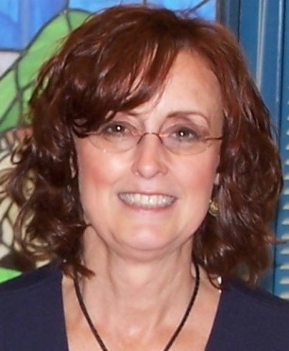

**2014 STEM Lecture Series:**

**Synergy in STEM: Math & the Sciences**

Lecture II – “*Collaborative Project-based Learning in Secondary Mathematics” –* Luajean Bryan

Wednesday, April 2, 2014, 5:30 – 6:30pm

122 Greve Hall, University of Tennessee

*Luajean Bryan is a Secondary Mathematics teacher at Walker Valley High School in Cleveland, TN*. *She has served as a high school math teacher for forty years and was recognized as Bradley County Teacher of the Year in 2008 and Tennessee Teacher of the Year 2009. Luajean Bryan was selected as a member of the USA Today All-USA Teacher Team in 2006. She has served on the Governor’s STEM Advisory Council since 2010, as a consultant with the International Council of Leadership in Education, Successful Practices Network, and as an adjunct faculty member of Tennessee Wesleyan College. She has presented at local, state, and national mathematics conferences with the National Council of Teachers of Mathematics and has articles published in NCTM’s professional journal Mathematics Teacher, earning a SNAP award for NCTM with her cover story in February 2007.  She co-authored the 2011 Glencoe-McGraw/Hill Pre-Calculus textbook and has received project-based learning grants from NEA, NCTM, and Toyota, among others. Luajean has a Master of Mathematics from the University of Tennessee and is currently pursuing her Ph.D. in Education, specializing in Curriculum, Instruction, and Assessment.*

* * * * * * * * * * * * * * * * * * * * * * *

For more information, please contact:

Dr. Susan Riechert – 974-6187 [sriecher@utk.edu](mailto:sriecher@utk.edu) or Dr. Susan Benner – 974-9598 [sbenner@utk.edu](mailto:sbenner@utk.edu)

Greve Hall location and UT parking map:

[http://www.utk.edu/maps/?searching=yes&find=Greve+Hall&search=Search#](http://www.utk.edu/maps/?searching=yes&find=Greve+Hall&search=Search)

<http://web.utk.edu/~pso/PDFs/UT%20Parking%20Map%202012-13.pdf>

Funded by a grant from the National Science Foundation, the NOYCE Scholarship grant, and the National Institute for Mathematical and Biological Synthesis, this lecture and workshop series serves to support the VolsTeach program at the University of Tennessee, Knoxville