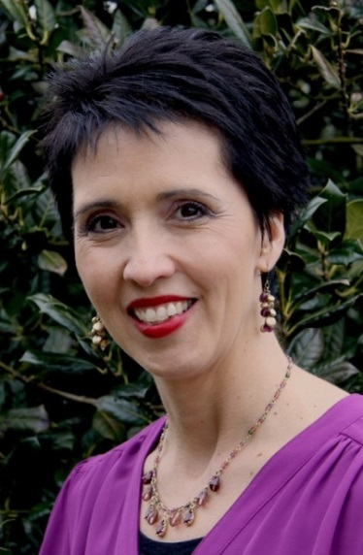

Wednesday, April 23, 2014, 5:30 – 6:30pm

122 Greve Hall, University of Tennessee

**2014 STEM Lecture Series:**

**Synergy in STEM: Math & the Sciences**

Lecture III – “*Bringing Life Back into the Biology Classroom: Utilizing Mathematical Models to Develop a Conceptual Understanding of Biology”* – Jennifer Dye

For more information, please contact:

Dr. Susan Riechert – 974-6187 [sriecher@utk.edu](mailto:sriecher@utk.edu) or Dr. Susan Benner – 974-9598 [sbenner@utk.edu](mailto:sbenner@utk.edu)

Greve Hall location and UT parking map:

[http://www.utk.edu/maps/?searching=yes&find=Greve+Hall&search=Search#](http://www.utk.edu/maps/?searching=yes&find=Greve+Hall&search=Search)

<http://web.utk.edu/~pso/PDFs/UT%20Parking%20Map%202012-13.pdf>

Jennifer Dye is the Head of the Science Department at Pope John Paul II High School. She holds a B.S. with a major in biology from Middle Tennessee State University and a M.S. from Vanderbilt University with research in Molecular Biology. Mrs. Dye teaches biology at all levels including Advanced Placement, coaches the Science Olympiad team and serves on several faculty committees. Her contribution to excellence in science teaching has been recognized repeatedly in Tennessee and nationally. She has published articles, presents at workshops and conventions, and serves as a master teacher in the GK12 TRIAD program at MTSU. Mrs. Dye has led the science department in a STEM redesign by taking a Physics First modeling approach with the students at Pope John Paul II High School.  She currently serves as member of Building Capacity for Tennessee Science Education (BCTSE) where her role is to help schools across the state make changes in their own curriculum to best meet the needs of students in STEM education in light of the Next Generation Science Standards.  As current president of the Tennessee Science Education Leadership Association, Mrs. Dye is working to assist science teachers, supervisors, and administrators in their awareness of the current trends and changes in science education.

Funded by a grant from the National Science Foundation, the NOYCE Scholarship grant, and the National Institute for Mathematical and Biological Synthesis, this lecture and workshop series serves to support the VolsTeach program at the University of Tennessee, Knoxville